1. **Training GUI Installation steps:**

**Windows:**

**1. Python:**

Download Python from <https://www.python.org/downloads/>.

Version 3.8 or above is preferred.

Run the below command in the command prompt and check the version:

python --version

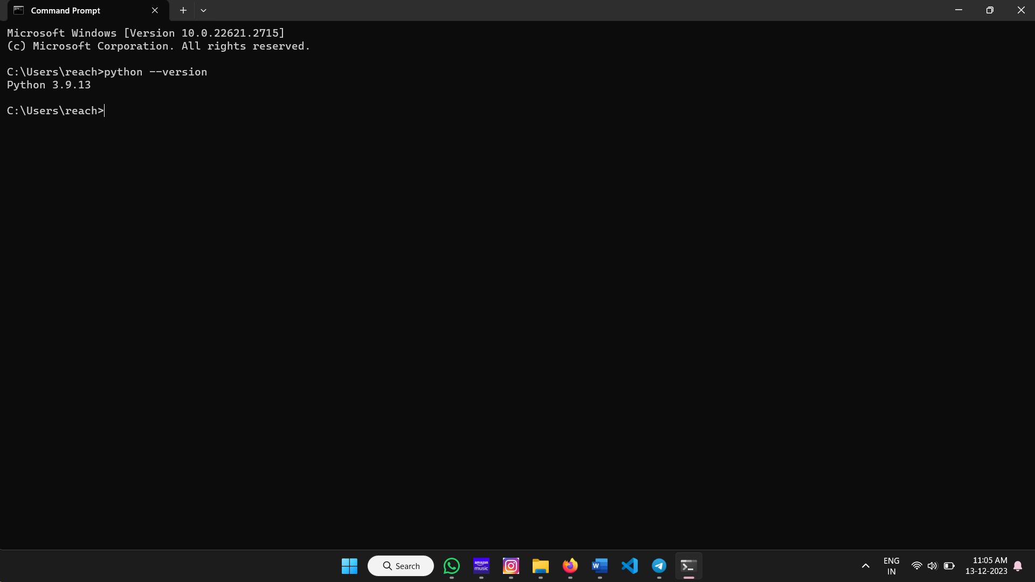

**2. Node.js:**

Download Node js from <https://nodejs.org/en/download>.

Version 18 or above is preferred.

Run the below command in the command prompt and check the version.

node --version

After completing all the installations, download the zip folder.

**Download the code**

1. Download the zip folder of the repository. Click “Code” and then click the “Download zip”.

Extract the zip folder.

**Installations for Visual Studio Code:**

1. Download Visual Studio Code from <https://code.visualstudio.com/>
2. Open Visual Studio code.

1. Click “File” and click “Open folder”.

1. Select the “gui_for_dlmodel” folder from extracted folder.

1. The code is loaded into the visual studio code.

**Installations for YOLO and labelImg tool:**

1. Click “Terminal” and click “New terminal”.

1. Go to the image-uploader directory by running the below command.

cd image-uploader

1. Run the below command in cmd to install npm.

npm install

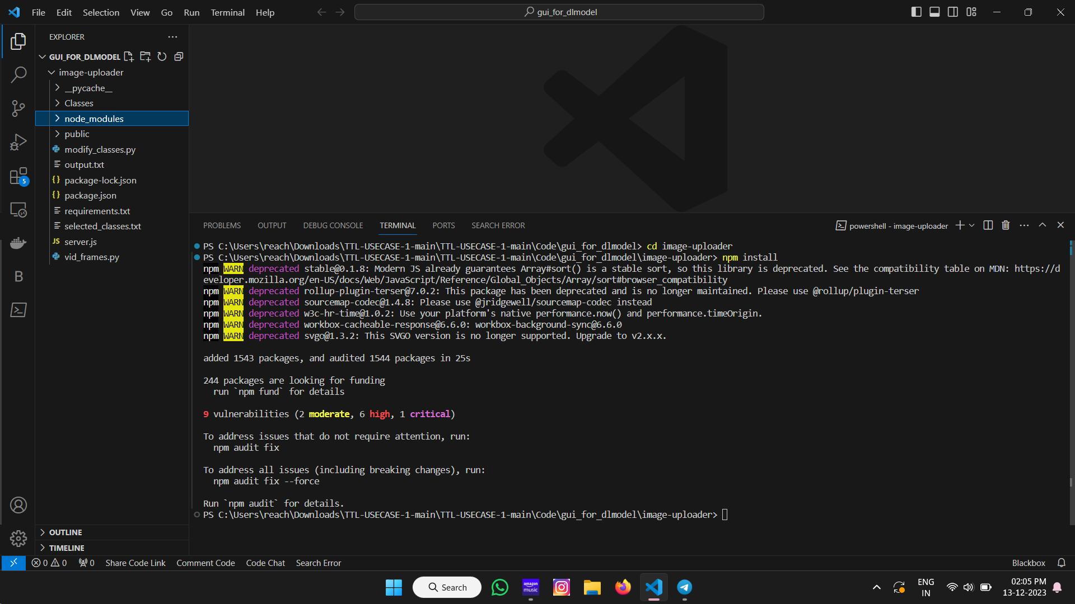

node_modules folder gets loaded in the folder after the npm installation is completed.

1. Go to the YOLOv5 directory by running the below command

cd image-uploader\public\yolov5

Run the below command to install the dependencies of YOLOv5:

python -m pip install -r requirements.txt

Go to public directory.

cd ..

1. Go to labelImg directory.

cd labelImg

Run the below command to install the dependencies of labelImg tool:

python -m pip install -r requirements\requirements-linux-python3.txt

Once you're in the correct directory, run the labelImg.py script using Python:

python labelImg.py

This should open up the labelImg graphical user interface, which is used for annotating images.

**Run the GUI**

Run the below command to run the GUI:

npm start 2>&1 | Tee-Object -FilePath "output.txt"

Then open <http://localhost:8000> in browser.

**Ubuntu Linux:**

**1. Python:** Check for the Python version in the terminal.

python --version

**2. Node.js:** Run the below commands in the terminal to install node js.

sudo apt update

sudo apt install nodejs

node -v

**3. npm:**

Run the below command in cmd to install npm.

sudo apt update

sudo apt install npm -y

npm –version

After completing all the installations, clone the training model GUI to perform data annotations.

**Download the code**

1. Download the zip folder of the repository. Click “Code” and then click the “Download zip”.

Extract the zip folder.

**Installations for YOLO and labelImg too**

1. Download Visual Studio Code from <https://code.visualstudio.com/>
2. Open visual studio code.

1. Click “File” and click “Open folder”.

1. Select the “gui_for_dlmodel” folder from extracted folder.

1. The code is loaded into the visual studio code.

**Installations for YOLO and labelImg tool**

1. Open visual studio code and open the downloaded folder (gui_for_dlmodel) in it.
2. Go to the YOLOv5 directory by running the below command

cd image-uploader\public\yolov5

Run the below command to install the dependencies of YOLOv5:

python -m pip install -r requirements.txt

Go to public directory.

cd ..

Go to labelImg directory.

cd labelImg

Run the below command to install the dependencies of labelImg tool:

python -m pip install -r requirements\requirements-linux-python3.txt

Once you're in the correct directory, run the labelImg.py script using Python:

python labelImg.py

This should open up the labelImg graphical user interface, which is used for annotating images.

Installations for Yolo model:

cd yolov5 pip install -r requirements.txt # install

This should open up the labelImg graphical user interface, which is used for annotating images.

**Run the GUI**

Run the below command to run the GUI:

Go to the path: gui_for_dlmodel\image-uploader>

**Command:**

npm start 2>&1 | tee output.txt

Then open <http://localhost:8000> in browser.

**GUI demo**

To easily navigate through the application, watch the GUI demo video and follow along with the step-by-step instructions provided in it.

<https://github.com/Kirtana-P/GUI-for-Data-Annotations/tree/main/1.%20Inference%20Phase-1/GUI_Demo_Video>